**Linkage of FRESH:COM to the openENTRANCE Platform (23.11.2020)**

Still missing: unit conversion that’s in line with nomenclature

Code and data available at: <https://github.com/tperger/FRESH-COM>

**Workflow**

The workflow showing the linkages of FRESH:COM to the openENTRANCE platform consists of the following steps:

1. Checking if the input data of FRESH:COM (in IAMC format), that will be exchanged with the openENTRANCE platform, is in line with the nomenclature defined in: <https://github.com/openENTRANCE/nomenclature>
2. Upload the model’s own input data (in IAMC format) to the platform.
3. Download relevant data from the platform (e.g. from own input data and GENeSYS-MOD) and filter according to model name, scenario, region, and aggregate in the time domain with the help of the *pyam* and *datetime* package, then prepare data.
4. Run the model and generate results.
5. Convert relevant results to the IAMC format and write to xlsx-file.
6. Upload output data file to openENTRANCE platform.
7. **Validation of the nomenclature**

With the help of the *nomenclature* module in python, each table (sheet) of the input excel-file is validated:

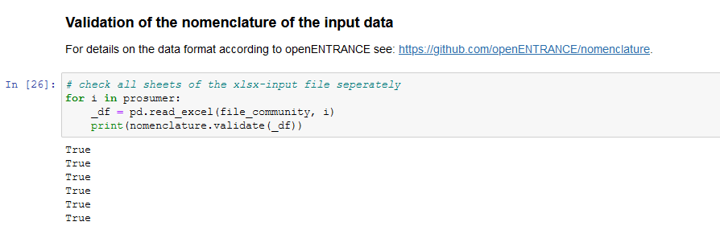

The input data contains hourly time series of electricity demand and PV generation data:

* Final Energy|Residential and Commercial|Electricity
* Secondary Energy|Electricity|Solar|PV

As well as installed capacities (battery energy storage systems (BESS) and PV):

* Maximum Storage|Electricity|Energy Storage System
* Minimum Storage|Electricity|Energy Storage System
* Maximum Charge|Electricity|Energy Storage System
* Maximum Discharge|Electricity|Energy Storage System
* Maximum Active power|Electricity|Solar

1. **Upload input data to openENTRANCE platform**

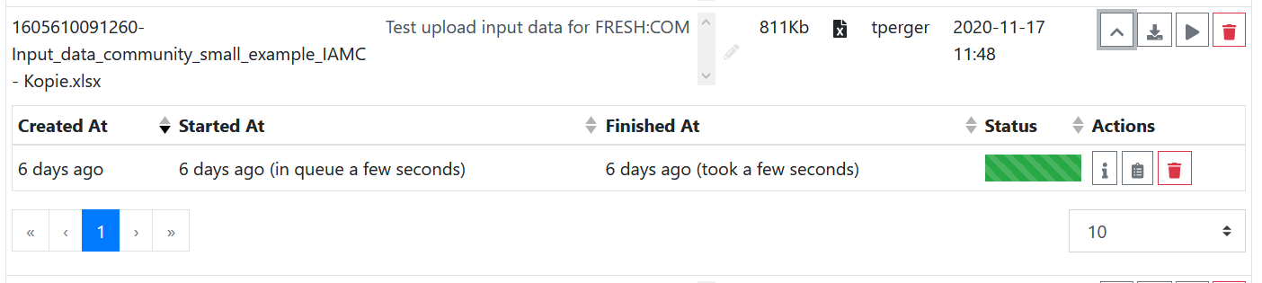

1. **Download data from the open platform**

First, all parameter necessary for a model run are defined (e.g. model name, scenario, and region). Then, load data from GENeSYS-MOD from IIASA scenario explorer:

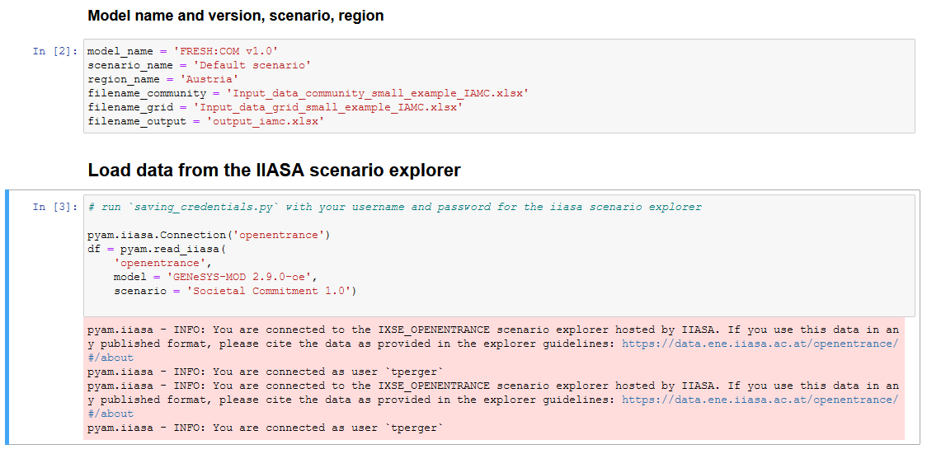

And save as *pandas* for further data processing within the model:

*df.as_pandas()*

Own data (from FRESH:COM) can also be downloaded to the program: 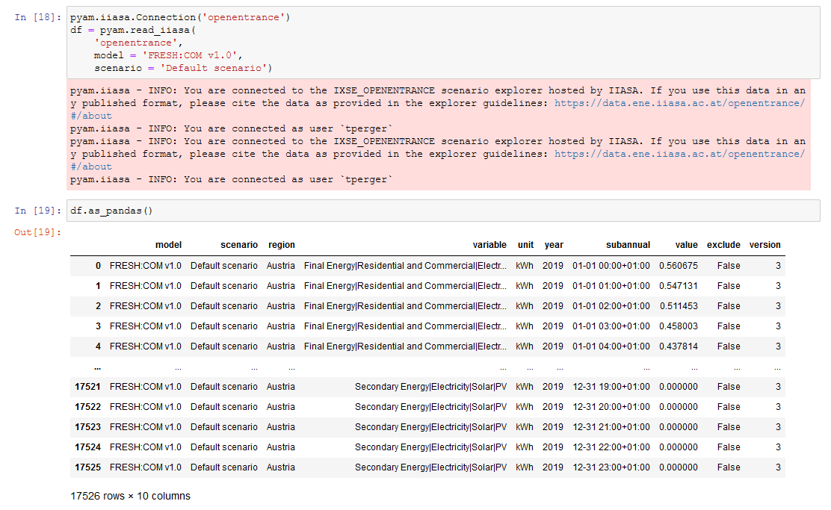



The data is filtered using the *pyam* package and further processed using own functions (e.g. *swap_subannual_for_time*), such that FRESH:COM can work with them.

1. **Run the model and generate results**

See Jupyter notebook on github for more information: <https://github.com/tperger/FRESH-COM>. The model works with *pyomo* <https://pyomo.readthedocs.io/en/stable/> and uses *gurobi* <https://www.gurobi.com/> as a solver.

1. **Convert relevant results to the IAMC format and write to xlsx-file**

Use a function *write_IAMC* to create a *pandas.DataFrame* with the same structure as *pyam.IamDataFrame*

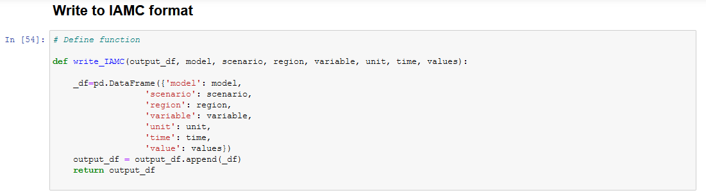

The following data is included in the output data file (each including yearly data and hourly time series):

* Secondary Energy|Electricity|Solar|PV
* Final Energy|Residential and Commercial|Electricity
* Emissions|CO2

And then write to an excel file:



Output file *output_iamc.xlsx* looks like this:

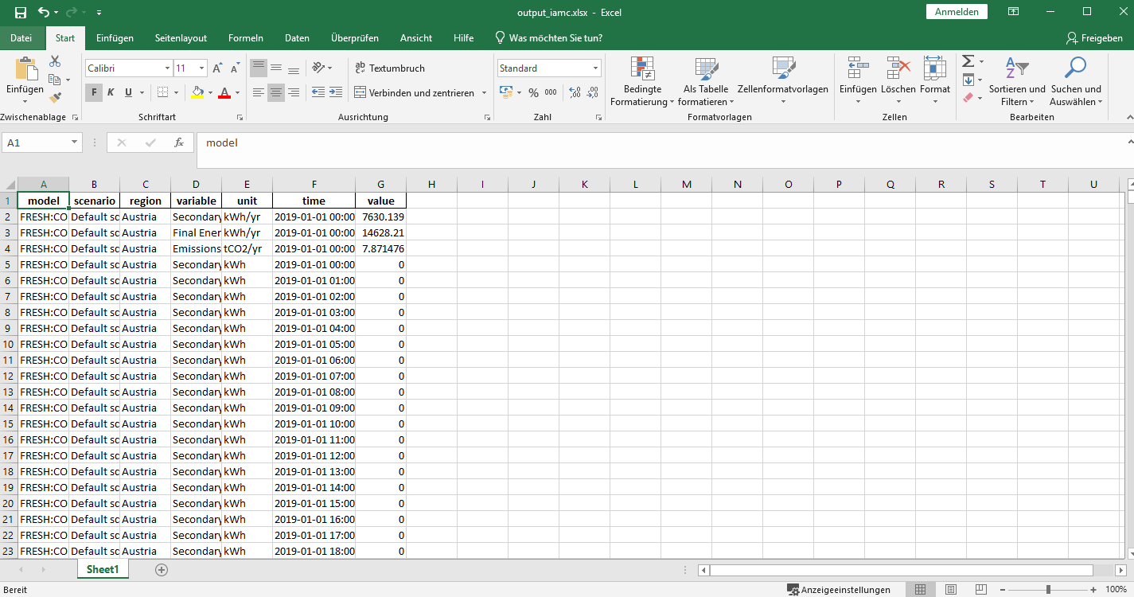

1. **Upload output data file to openENTRANCE platform**

Upload to the scenario explorer (show job info):

